Block Management Use Case

Submitted to

Alpha Payments Cloud


Tarang Software Technologies Private Limited
Tarang Towers,
#400/2, Whitefield 100 ft road,
Hoody circle,
Bangalore, India
Phone: +91-80-41157777
WEB: www.tarangtech.com

© This document is exclusive property of Tarang software Technologies Private Limited. No part of this may reproduced in any form without written permission.

Document Change History

Ver# | Editor | Date | Reviewer | Approver | Changes made
0.1 | Vikash Ranjan | 7th Sep 2012 | Bindu V |  | Draft Version
1.0 | Vikash Ranjan | 11th Sep 2012 | Bindu V |  | Base Version
1.01 | Vikash Ranjan | 25th Sep 2012 | Ronan |  | Updated version with Ronan’ review comments
1.02 | Vikash Ranjan | 28th Sep 2012 | Ronan |  | Updates with comments shared on 26th Sep

Table of Contents
1 Introduction 4
2 Use Case: add/edit Blocks 4
2.1 User Interface Information 5
2.1.1 User Interface details for Manage Blocks 5
3 Use Case: search blocks 5
3.1 User Interface Information 6
3.1.1 User Interface details 6

Introduction

This document describes the use cases for Search Block, Manage Block configuration for the merchant in APC System.

Use Case: add/edit Blocks

Title | Add/Edit Blocks
Requirement ID | RID-1117
Actors | APC User with appropriate privilege.
Description | Allows the Actor to configure Manage Blocks for Merchant, Corporate, Bank or APC level
Use case trigger | - Actor selects “Add” from the “Manage Block” menu in APC.  - Actor selects “Edit” from the “Manage Block” menu against the corresponding Processor record to edit the details in APC.
Main flow / Flow of Events | - Selection of Add/Edit in 'Manage Block' navigates to corresponding screen.  - Details of Input field are as below:  Scope,  Block Type,  Block Category,  Start Date,  End Date,  Value,  Reason  - Actor shall enter/edit the relevant information & Click on Save.  - APC System will validate the information entered & save the details in the DB. The created Block will be listed in Block List.
Sub-flow/Alternate Flows/ Scenarios | N/A
Assumptions
Pre-conditions | Actor is logged into the Application with appropriate permissions
Post-conditions | - Add - New Block will successfully be created in the system.  - Edit – the edited details of the Block shall get successfully updated in the DB.
Status | Open
Issues | Identify the Category List and the default block duration for each category
Business Rules | - Actor can add Block on Block Category as below:  Black, Gray, White.  - Start date will default to today’s date for the new block record  - Status will be set as Active by default for new record, the status will be non editable in the new record  - IF the Block date is elapsed, the block is set as inactive  - If Block category type is 'Black' then it blocks the transaction based on Block Type and generates alerts for Merchant.  - If Block category type is 'Grey' then it allows the transaction based on Block Type and generates alerts for Merchant.  - If Block category type is 'White' then it allows the transaction with bypassing the applicable velocity check on the same.  - Value will be a comma separated input that can be entered based on the Block type selected Example: if IP is the Block type selected, then the Value field can have one or more values entered  - The Block record can be set at the APC level, which is applicable as global blocks, if the scope is Bank level then the blocks are available at the selected bank level and all the associated corporate and Merchants. Similarly for the blocks at corporate level. If the block is defined at the merchant level, then the existing global level or hierarchy level block is overridden by the block set at merchant level.  - The block record will return the response with TXN_PG_BLOCKED or TXN_PG_GRAY alert types for the blocked or failure transaction records of Black and Gray list. The transaction response code is set at the code level. Based on the block type an alert can be configured in alert config. The mapping of the alert for the Block can be done in the alert config screen of the storyboard.

User Interface Information

User Interface details for Manage Blocks
Refer Manage Blocks screen of the storyboard

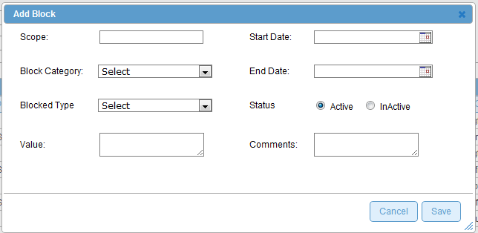

Use Case: search blocks
Title | Search Blocks
Requirement ID | RID-1118
Actors | APC User with appropriate privilege
Description | Actor should be able to search for the Blocks associated for a merchant/Corporate/Bank/APC level
Use case trigger | - When Actor selects the “Manage Block” option from the main menu to search/view Merchant List
Main flow / Flow of Events | - On selecting the “Manage Block“option from the main menu, system navigates to screen which display the list of Block in APC for the selected merchant.  - Actor shall enter the search criteria & click on “Search” button.  Search criteria’s :  Scope,  Block Type,  Block Category,  Value  - System shall build the query based on the criteria entered & retrieve the relevant records from the DB & display it in the listing in the below mentioned format:  [Block Id, MID, Block Type, Block Category, Value, Start Date, End Date, Blocked By, Comments, Status]
Sub-flow/Alternate Flows/ Scenarios | 2a. If the actor does not choose to enter any data in the search criteria’s then the system shall retrieve all the Block records.  2b. If there are no relevant records for the search criteria chosen; system should display an appropriate message saying “No Records found.”
Assumptions
Pre-conditions | Actor should be logged into the system & has the appropriate privilege to manage blocks for a merchant.
Post-conditions | - Actor is able to retrieve the relevant Block records from the system based on the search criteria chosen.
Status | Open
Issues | -
Business Rules | Search – Query should be for partial search. I.e. like “%string%”. So the minimal search keys that you enter should retrieve the maximum information. For ex: Search By SCOPE – “C” should retrieve the entire Merchant with the alphabet “c” in their names.  The scope access shall be as per the logged in user permission. If the user is in APC level, the user can view all blocks of different scope. If logged in user is at merchant level, and then the blocks related to log in user only will be listed.  E.g. a user for merchant A cannot look at entries for merchant B

Note: API support for the negative and block list shall be part of later releases.

User Interface Information

User Interface details

Refer Manage Blocks screen of the storyboard

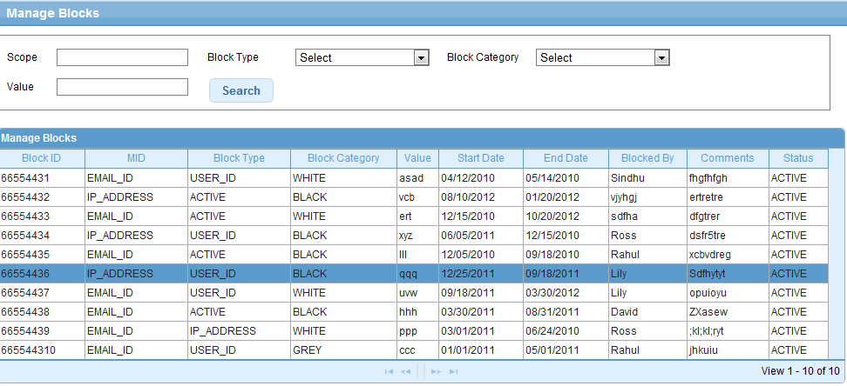

Validations for search Blocks

Id | Parameter Name | Field Type | Special characters | Validations | Field Length | Possible Values | Additional Condition | Mandatory
1 | Scope | Text Box |  |  |  | APC/Bank/Corporate/Merchant
2 | Block type | Drop down
3 | Block Category | Drop down
4 | Value | Text Box

